- Season and Visit reason
The need to simulate p-values in your Chi-square test comes from violations of the assumptions behind the standard Chi-square test.
Warning error = "Chi-squared approximation may be incorrect" This means the assumptions of the Chi-square test may not be met.
Chi-square Test Assumptions:
Expected frequencies in each cell should be ≥ 5
Observations should be independent
Table dimensions should not be too sparse (too many rows/columns with 0s or small counts)
My data has some visit reasons with very low counts in certain seasons. This causes the expected frequencies (calculated internally during the test) to fall below 5 Standard Chi-square p-values to become unreliable.
Therefore, Monte Carlo Simulation is done. Like chisq.test(season_reason, simulate.p.value = TRUE, B = 10000). Where R Randomly shuffle the table structure 10,000 times. Recalculate the Chi-square statistic for each. Compare observed Chi-square statistic to this simulated distribution. This gives a more accurate p-value, especially when assumptions are violated.

Result:
- Pearson's Chi-squared test with simulated p-value (based on 10000
replicates)
data: season_reason
X-squared = 337.32, df = NA, p-value = 9.999e-05
The p-value is far below 0.05, so we reject the null hypothesis that season and visit.reason are independent. The reason for a visit is significantly associated with the season – certain activities are much more common in specific seasons.
High Chi-square value also supports the conclusion that season and visit reason are dependent — i.e., they influence each other.
- Strength association
X^2 df P(> X^2)
Likelihood Ratio 381.29 66 0
Pearson 337.32 66 0

Phi-Coefficient : NA
Contingency Coeff.: 0.505
Cramer's V : 0.414
Cramér’s V = 0.414: This is a measure of association strength, ranging from 0 (no association) to 1 (perfect association).
Rule of thumb: 0.1 = weak, 0.3 = moderate, and 0.5 = strong. So here, Cramér’s V = 0.414 indicates a moderate-to-strong association between season and visit reason.
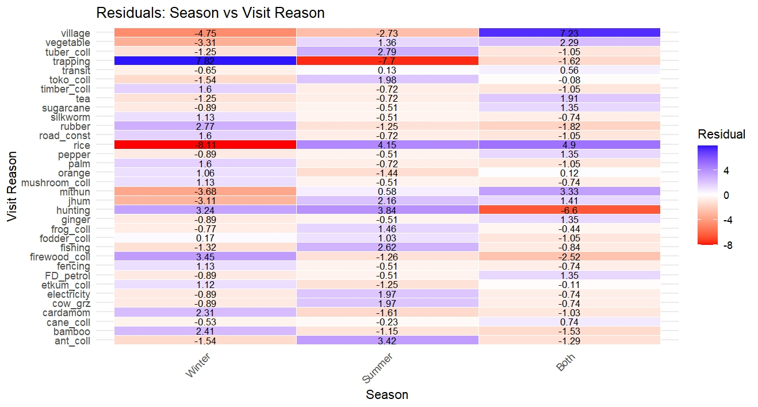
The standardized residual is basically: (Observed - Expected) / Standard Error
Residual Value | Interpretation
> +2 | Observed value is much higher than expected
< –2 | Observed value is much lower than expected
Between –2 and +2 | Nothing unusual — expected and observed are similar

#### The residual tells which activities (visit reasons) happened more or less often in each season than expected if there was no pattern or unrelated.
Season | Visit Reason | Residual | interpretation
Winter | Trapping | 6.0 | Trapping is very common in winter — much more than expected.
Winter | Hunting | 5.3 | Hunting is also very common in winter — much more than expected.
Both | Mithun | 3.5 | Mithun-related visits happen more in both seasons than expected.
Both | Fencing | 2.9 | Fencing are also more common in both seasons.

Season | Visit Reason | Residual | Interpretation
Summer | Rice | –3.1 | People went for rice less than expected in summer.
Winter | Ginger | –2.5 | Ginger collection happened less in winter.
Summer | Firewood | –2.8 | Firewood collections are less in summer than expected.
Winter | Fishing | –3.3 | Fishing happens less in winter.

Since season and visit.reason are not independent, including both as covariates in the same model may lead to --- a) Multicollinearity (they will overlap in meaning) b) Overfitting or inflated standard errors c) difficulty in interpreting which variable is driving the detection probability.
###Standard errors tell us how confident we are about the effect of a variable.
When you include two variables that are highly related (like season and visit.reason), the model gets confused about which one is actually causing the effect. This makes the estimates unstable and less reliable giving large Standard errors.
Therefore, If we model human activity’s effect on detection prob. Then we can use visit.reason, but if modelling ecological or seasonal dynamics, then we can use season.

- Visit reason and total day per year
If Assumptions Are Met | Test to Use

Normal distribution, equal variances | One-Way ANOVA

If not normal / unequal variances | Kruskal–Wallis Test (non-parametric alternative)

- First, do normality test to understand data distribution.
- The data was not normally distributed so not ANOVA, but Kruskal wallis test
Result: Kruskal-Wallis rank sum test
data: total.day.per.year by visit.reason
Kruskal-Wallis chi-squared = 433.97, df = 33, p-value < 2.2e-16
#### High chi -sq value shows strong difference between groups
#### p -value less then 0.05, the result is highly significant.
Therefore, there is a highly significant difference in the number of days per year people spend in the AOK, depending on their visit reason. We take both the covariates as independent variables.

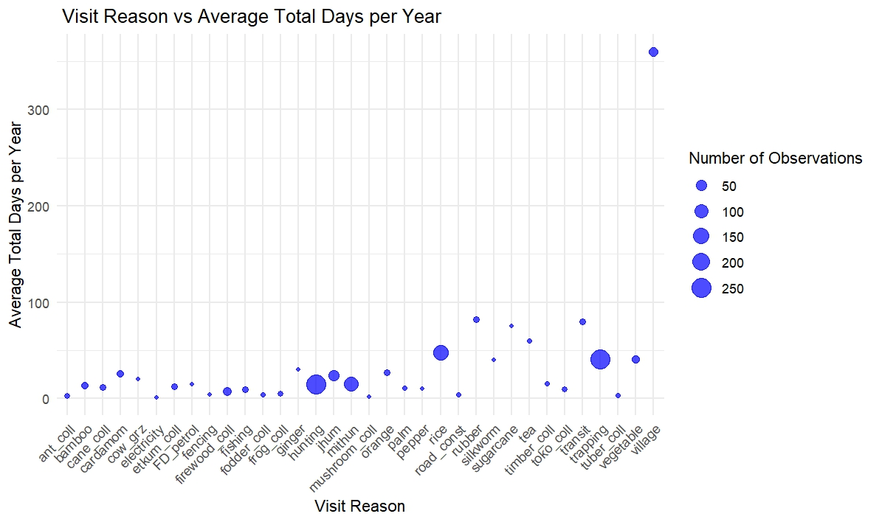

- Season and total days per year.

Kruskal-Wallis rank sum test
data: total.day.per.year by season
Kruskal-Wallis chi-squared = 179.59, df = 2, p-value < 2.2e-16

The P value is less than 0.05, therefore the result is highly significant. There is a very strong difference between number of days people spend in the AOK based on season.

- Distance and visit reason
Kruskal-Wallis rank sum test

data: distance by visit.reason
Kruskal-Wallis chi-squared = 150.47, df = 33, p-value < 2.2e-16
The average distance travelled by people in AOK is significantly different depending on the activities (Visit reasons)

- Distance and total day per year
Before log transform
Spearman's rank correlation rho

data: ob.cov$distance and ob.cov$total.day.per.year
S = 167462045, p-value = 0.1071
alternative hypothesis: true rho is not equal to 0
sample estimates:
rho -0.05137924

rho value is low, showing very weak negative correlation, thus when distance increases, the number of days slightly decreases, but the effect is minute. P value is above 0.05, so the result is not statistically significant, i.e., there is no meaningful relationship between distance and total days spend per year.

####After log transformation
Spearman's rank correlation rho
data: ob.cov$log_distance and ob.cov$log_total.day.per.year
S = 167462045, p-value = 0.1071
alternative hypothesis: true rho is not equal to 0
sample estimates:
rho
-0.05137924
####Not difference

- Distance and season
Kruskal-Wallis rank sum test

data: distance by season
Kruskal-Wallis chi-squared = 7.7014, df = 2, p-value = 0.02126
P value less than 0.05, thus statistically significant. i.e., there is difference in distance travel in each season.

Final conclusion:
- Visit reason (categorical detection covariate) = keep it as it explains the variations in human activity and can influence detection probability and occupancy is human modified areas.
Need to Regroup reason to lesser categories, like subsistence (hunting, trapping, fishing etc), Agriculture (rice, jhum, ginger etc), collection (firewood, timber etc), others
- Total day per year (continuous covariate) = keep, as it reflects effort, intensity and possibly detection.
- Distance (continuous covariate) = keep it, reflects effort.
- Season = maybe drop it as it overlaps with visit reasons (strong association) to avoid multicollinearity.
- Total day per year is highly correlated with day per month, so just chose one to avoid collinearity.
- Distance – can be meaning to see human access and effort, so keep it.

